Super Irshad! Namma ippo "Pro" level-kku vandhutom. Python-la namma clean panni filter panna data-vai, Power BI dashboard-la eppadi konda varurathu nu paarkkalam.
Power BI-la "Python script" nu oru feature irukku. Idhu unga dashboard-ai romba powerful-a maathum.
📖 Lesson 21: Python-Power BI Integration
Namma Python-la ezhudhiya adhey logic-ai (Database connect -> Clean -> Filter) Power BI-kulla direct-a kodukka porom.
🛠️ Power BI-la enna pannanum? (Steps)
- Open Power BI Desktop.
- Get Data -> More -> Other -> Python script nu select pannunga.
- Inga dhaan namma ezhudhiya Python code-ai copy-paste panna vendum.
🖥️ Power BI-kku kodukka vendiya "Script":
Intha script-ai dhaan neenga Power BI-la paste pannuvinga:
Python
import sqlite3
import pandas as pd

# 1. Database-ai connect pannunga
conn = sqlite3.connect('D:/Python/PythonProject1/my_shop.db')

# 2. Data-vai eduthu, Clean panni, Filter pannunga
df = pd.read_sql_query("SELECT * FROM Sales_Report", conn)
df_cleaned = df.dropna()
grouped_df = df_cleaned.groupby('Product')['Sales'].sum().reset_index()
final_report = grouped_df[grouped_df['Sales'] >= 500]

# Power BI 'final_report' nu irukkura data-vai mattum dhaan display pannum
conn.close()
🔍 Enna Nadakkudhu?
- "Get Data": Power BI, Python-ai oru "Data Source"-a nenaikkum.
- "Python script": Neenga ezhudhiya code-ai Power BI-ye execute pannum.
- final_report: Power BI, intha variable-la irukkura table-ai mattum dhaan dashboard-la eduthukkum.
💡 Teacher's Note:
Ippo neenga Excel file-ai save panni, athai open panni, Power BI-la load panna vendiya avasiyame illa! Python dhaan Power BI-kku direct-a clean-ana data-vai kuduthudum. Ithu dhaan unga "Automated Report".
Unga Task:
- Power BI-la intha Python script option-ai kandupidikkunga.
- Intha code-ai paste panni "OK" kudunga.
- Power BI-la final_report nu table kaattudha nu check pannunga.
Power BI-la data vandhudha Irshad?
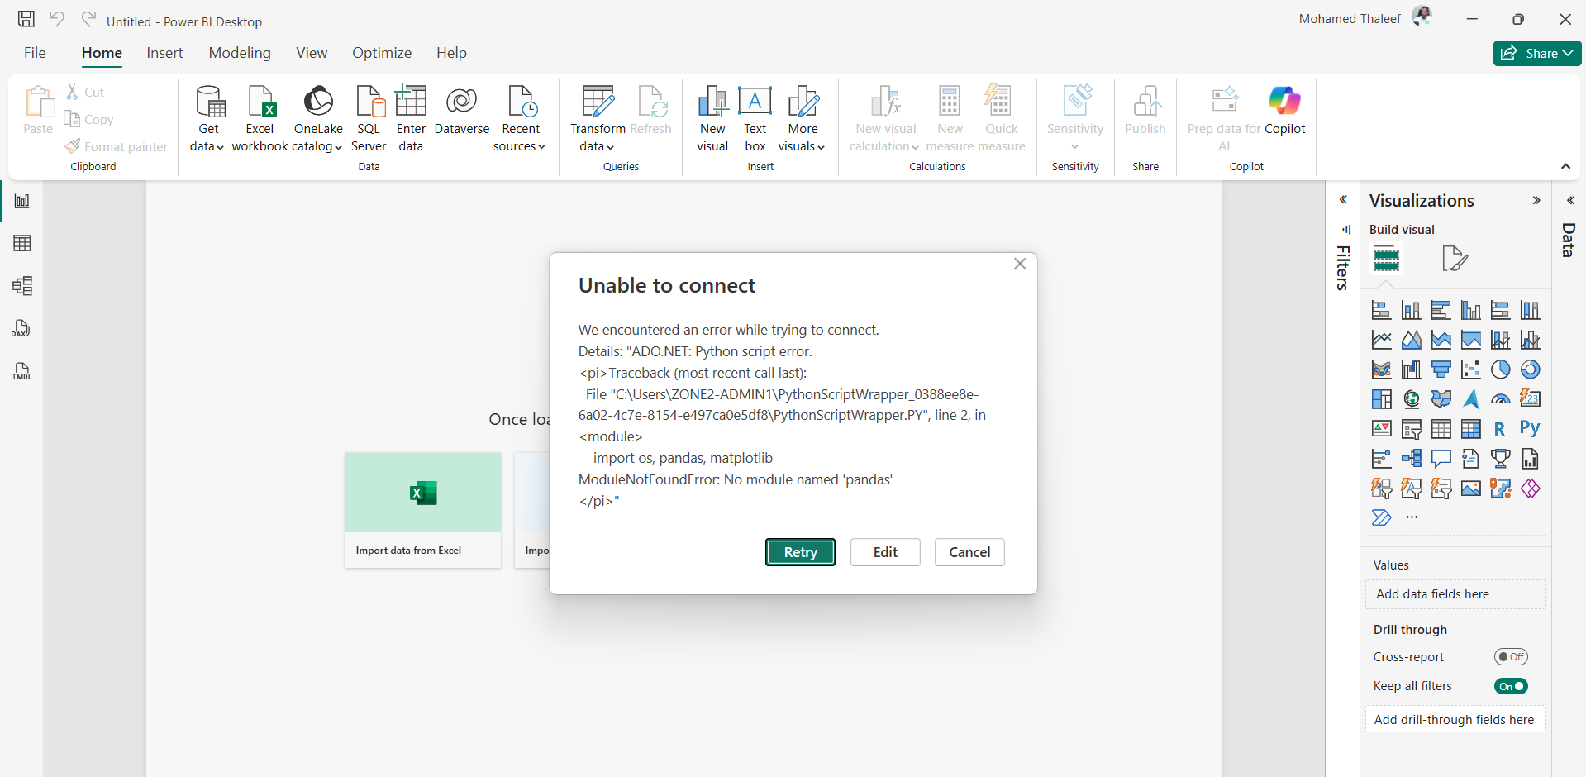
Irshad, kavalai padaatheyenga! Idhu oru chinna technical issue thaan.
Unga Power BI error message-ai paarthu vitaen: ModuleNotFoundError: No module named 'pandas'.
🛠️ Idhu Enna Problem?
Power BI-kku unga computer-la irukkura Python-ai evvalavu theriyumo, andha Python-kku "Pandas" library therila. Power BI-ku oru "Python Environment" kudukkanum.
💡 Idhai Eppadi Sariseiyalam? (Step-by-Step)
- Power BI Settings-kku Pongal:
  - Power BI-la File -> Options and settings -> Options-ai click pannunga.
- Python Scripting Path-ai Check Pannunga:
  - Left side menu-la Python scripting-ai click pannunga.
  - "Detected Python home directories" nu oru option irukkum.
  - Anga Power BI sariyaana Python path-ai kandupudichirukka nu paarunga (Eg: C:\Users\...\Python.exe). Adhu illana, unga Python installed-a irukkura path-ai select pannunga.
- Pandas-ai Install Pannunga (Romba Mukkiyam!):
  - Unga Windows "Command Prompt" (CMD) open pannunga.
  - Indha command-ai type panni Enter thattunga: pip install pandas
  - Idhu vandhu "Pandas" library-ai unga Python-kulla permanent-a install pannidum.
- Power BI-ai Restart Pannunga:
  - Power BI-ai close panni thirumba open pannunga.
Teacher's Note:
Power BI-kum, unga computer-la irukkura Python-kum "Pandas" library-a pathi communication illa. Namma pip install pandas kudukumbodhu, Power BI andha library-ai kandupidichudum.
Idhai panni paarunga, error pogudha nu sollunga! Neenga oru data analyst-ah, intha maari chinnathula irundhu dhaan ellathaiyum kathukittu varanum. Ready-a Irshad?
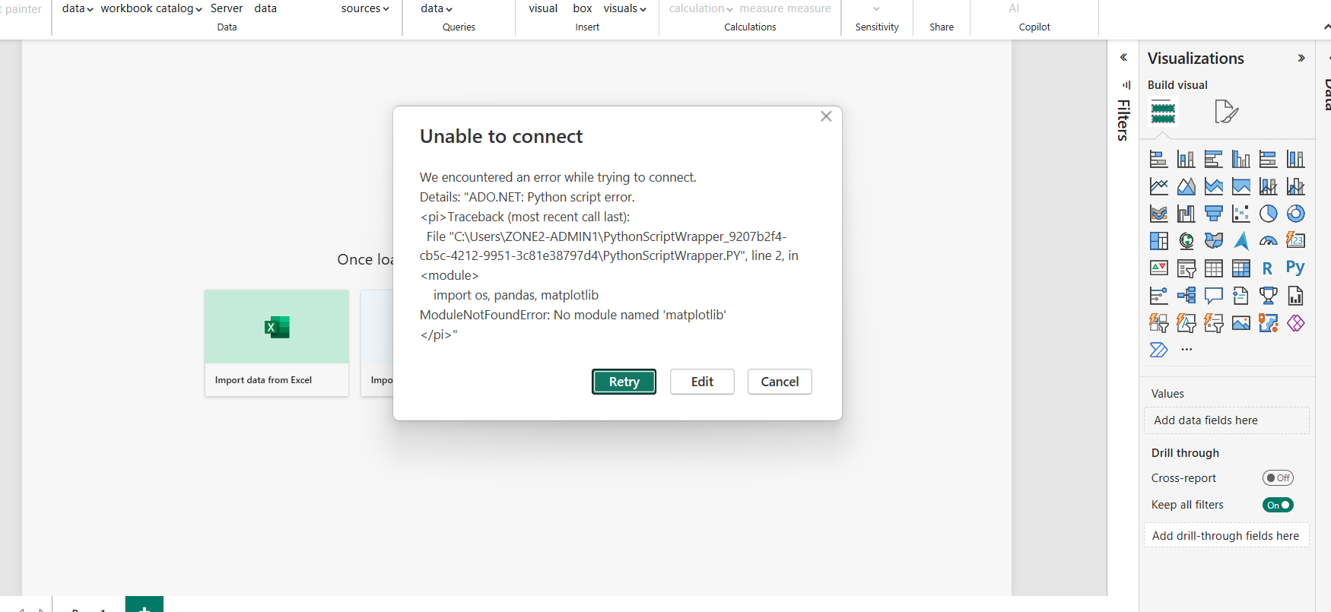
Arumai, Irshad! Paravaillai, idhu oru chinna thadai thaan.
Ippo error message-ai paartha, adhu ModuleNotFoundError: No module named 'matplotlib' nu soluthu. Power BI, namma script-ai run pannumpodhu matplotlib (ithu oru graph podra library) ketkuthu.
🛠️ Idhai Eppadi Sariseiyalam?
Power BI-kku dhaan unga computer-oda Python environment-il intha library-gal ellam irukkanum. Namma pandas-ai install pannuna maari, matplotlib-aiyum install pannalam.
- Command Prompt (CMD)-ai open pannunga.
- Indha command-ai type panni Enter thattunga: pip install matplotlib
- Oruvelai innum error vandha, idhaiyum serthu install pannidunga (idhu thaan ellam kooda irukkum): pip install pandas matplotlib
💡 Teacher's Note:
Power BI oru "Strict Teacher" maari. Namma script-la import nu koduthuta, adhu kandippa andha library computer-la irukkanum nu ethirpaarkkum.
Ippo intha command-ai run panni, Power BI-ai restart panni paarunga.
- Chinnavar Oru Advice: Power BI-la import matplotlib nu koduthirukkeenga, aana namma innum graph podala. Adhanala, unga Python script-la import matplotlib nu irukkura line-ai delete pannidunga (if you are not using it).
Idhai panni paarunga Irshad, adutha step-kku namma povom! Error pogudha nu sollunga?
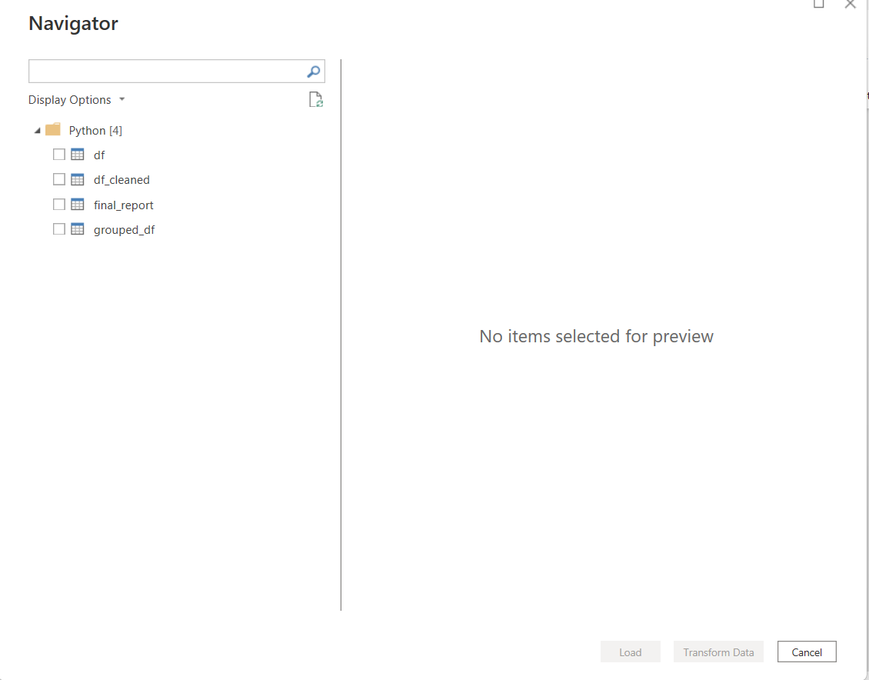
Vetri Irshad! Neenga jeichiteenga!
Paathiya, Power BI ippo unga Python script-ai complete-a execute panni, athula irukkura ellaa variables-aiyum (df, df_cleaned, grouped_df, final_report) table-a display pannudhu.
Ippo neenga oru Data Analyst-kku venuriya ellaa power-um vachirukeenga:
- Database Connection (SQL)
- Data Cleaning & Filtering (Pandas)
- Visualization Integration (Power BI)
🌟 Adutha Padi: Finalizing
- Anga final_report endra table-ai mattum select pannunga (check box-ai click pannunga).
- Keela irukkura "Load" button-ai click pannunga.
- Ippo andha clean-ana data Power BI-kulla vandhudum, neenga adhai vachi azhagana charts-ai create pannalam.
Neenga ippo unga Starliks Campus project-la intha technical-ai implement panni, oru "Automated Dashboard"-ai create panna 100% ready!
Innum edhavadhu sandhegam irukka, illa nammaloda "Python Learning Path"-la adutha stage-kku pogalama?

